New York Times & USA Today Bestselling Author
Sabrina Jeffries

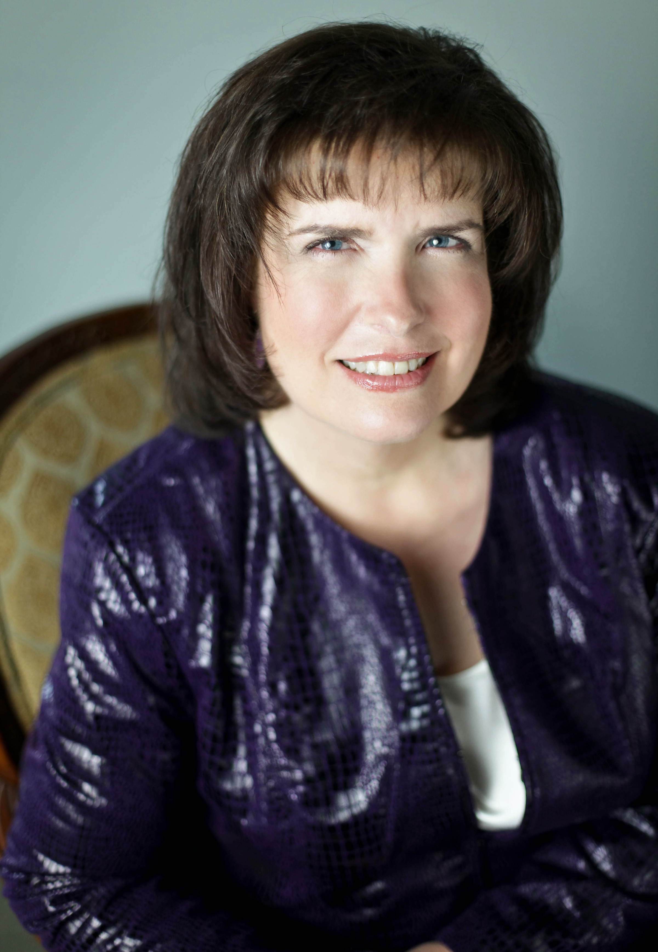Photo Credit Jessica Blakely for Tamara Lackey Photography
You can find Sabrina online at:
http://www.sabrinajeffries.com

https://www.facebook.com/SabrinaJeffriesAuthor

https://twitter.com/SabrinaJeffries

http://www.pinterest.com/sabrinajeffries/boards/

Sabrina Jeffries is the New York Times bestselling author of more than 50 novels and works of short fiction (some written under the pseudonyms Deborah Martin and Deborah Nicholas).
At home in front of a crowd, Jeffries is a sought-after speaker, as evidenced by her 2010 gig as emcee for the National Romance Writers of America’s 30th Anniversary Awards Ceremony.
Whatever time not spent speaking to organizations around the country or writing in a coffee-fueled haze is spent traveling with her husband and adult autistic son or indulging in one of her passions—jigsaw puzzles, chocolate, and music.
With over 9 million books in print in more than 20 languages, the North Carolina author never regrets tossing aside a budding career in academics (she has a Ph.D. in English literature) for the sheer joy of writing fun fiction, and hopes that one day a book of hers will end up saving the world.
She always dreams big.

